



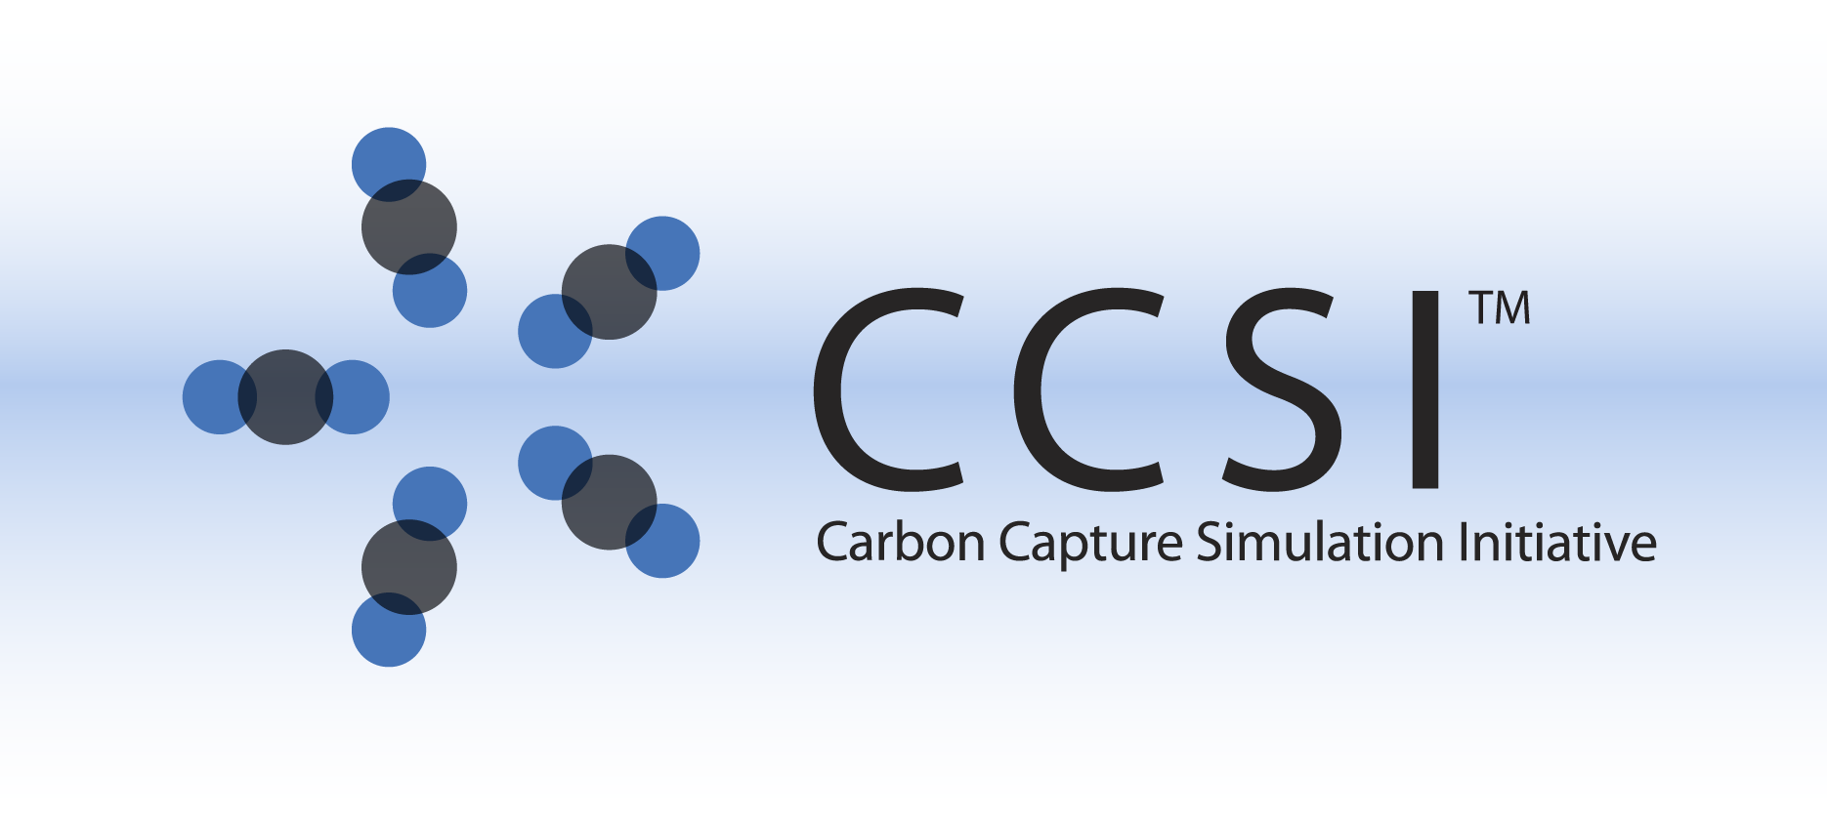

Membrane Model

User Manual

Version 2.0.1

Aug 2019

Copyright (c) 2012 - 2019

**Copyright Notice**

Membrane Model was produced under the DOE Carbon Capture Simulation Initiative (CCSI), and is copyright (c) 2012 - 2019 by the software owners: Oak Ridge Institute for Science and Education (ORISE), TRIAD National Security, LLC., Lawrence Livermore National Security, LLC., The Regents of the University of California, through Lawrence Berkeley National Laboratory, Battelle Memorial Institute, Pacific Northwest Division through Pacific Northwest National Laboratory, Carnegie Mellon University, West Virginia University, Boston University, the Trustees of Princeton University, The University of Texas at Austin, URS Energy & Construction, Inc., et al.. All rights reserved.

NOTICE. This Software was developed under funding from the U.S. Department of Energy and the U.S. Government consequently retains certain rights. As such, the U.S. Government has been granted for itself and others acting on its behalf a paid-up, nonexclusive, irrevocable, worldwide license in the Software to reproduce, distribute copies to the public, prepare derivative works, and perform publicly and display publicly, and to permit other to do so.

**License Agreement**

Membrane Model Copyright (c) 2012 - 2019, by the software owners: Oak Ridge Institute for Science and Education (ORISE), TRIAD National Security, LLC., Lawrence Livermore National Security, LLC., The Regents of the University of California, through Lawrence Berkeley National Laboratory, Battelle Memorial Institute, Pacific Northwest Division through Pacific Northwest National Laboratory, Carnegie Mellon University, West Virginia University, Boston University, the Trustees of Princeton University, The University of Texas at Austin, URS Energy & Construction, Inc., et al. All rights reserved.

Redistribution and use in source and binary forms, with or without modification, are permitted provided that the following conditions are met:

1. Redistributions of source code must retain the above copyright notice, this list of conditions and the following disclaimer.
2. Redistributions in binary form must reproduce the above copyright notice, this list of conditions and the following disclaimer in the documentation and/or other materials provided with the distribution.
3. Neither the name of the Carbon Capture Simulation Initiative, U.S. Dept. of Energy, the National Energy Technology Laboratory, Oak Ridge Institute for Science and Education (ORISE), TRIAD National Security, LLC., Lawrence Livermore National Security, LLC., the University of California, Lawrence Berkeley National Laboratory, Battelle Memorial Institute, Pacific Northwest National Laboratory, Carnegie Mellon University, West Virginia University, Boston University, the Trustees of Princeton University, the University of Texas at Austin, URS Energy & Construction, Inc., nor the names of its contributors may be used to endorse or promote products derived from this software without specific prior written permission.

THIS SOFTWARE IS PROVIDED BY THE COPYRIGHT HOLDERS AND CONTRIBUTORS "AS IS" AND ANY EXPRESS OR IMPLIED WARRANTIES, INCLUDING, BUT NOT LIMITED TO, THE IMPLIED WARRANTIES OF MERCHANTABILITY AND FITNESS FOR A PARTICULAR PURPOSE ARE DISCLAIMED. IN NO EVENT SHALL THE COPYRIGHT OWNER OR CONTRIBUTORS BE LIABLE FOR ANY DIRECT, INDIRECT, INCIDENTAL, SPECIAL, EXEMPLARY, OR CONSEQUENTIAL DAMAGES (INCLUDING, BUT NOT LIMITED TO, PROCUREMENT OF SUBSTITUTE GOODS OR SERVICES; LOSS OF USE, DATA, OR PROFITS; OR BUSINESS INTERRUPTION) HOWEVER CAUSED AND ON ANY THEORY OF LIABILITY, WHETHER IN CONTRACT, STRICT LIABILITY, OR TORT (INCLUDING NEGLIGENCE OR OTHERWISE) ARISING IN ANY WAY OUT OF THE USE OF THIS SOFTWARE, EVEN IF ADVISED OF THE POSSIBILITY OF SUCH DAMAGE.

You are under no obligation whatsoever to provide any bug fixes, patches, or upgrades to the features, functionality or performance of the source code ("Enhancements") to anyone; however, if you choose to make your Enhancements available either publicly, or directly to Lawrence Berkeley National Laboratory, without imposing a separate written license agreement for such Enhancements, then you hereby grant the following license: a non-exclusive, royalty-free perpetual license to install, use, modify, prepare derivative works, incorporate into other computer software, distribute, and sublicense such enhancements or derivative works thereof, in binary and source code form. This material was produced under the DOE Carbon Capture Simulation.

1. Version Log

| Version Number | Release Date | Description |
| --- | --- | --- |
| 2.0.1 | 08/15/2019 | Patch update |
| 2.0.0 | 03/31/2018 | Initial Open Source release |
| 2015.06.0 | 06/30/2015 | 2015 June IAB Release – The manual was updated to reflect modelling of pressure drop in the shell side of membrane model. The results shown in this manual have been generated using ACM V8.4 and Aspen Properties V8.4. |

Table of Contents

1.0 Version Log iv

Membrane Model 1

1.0 Introduction 1

2.0 General Information 1

2.1 Overview 1

2.2 System/Installation Requirements 2

2.3 Model Assumptions 2

3.0 Model Structure 3

3.1 IO Structure and Reactor Dimensions 3

3.2 Membrane Transport Model 4

3.3 Membrane Module Model 5

3.4 Hollow Fiber Module Properties 6

4.0 Tutorial 7

5.0 References 11

List of Figures

Figure 1: HFGP membrane device model schematic. 1

Figure 2: Asymmetric membrane. 4

Figure 3: PermeateM2 stream results. 11

Figure 4: RetenateM2 stream results. 11

List of Tables

Table 1: Hollow Fiber Module Properties 6

Table 2: M1 Device Variables 8

Table 3: M1 Gas Feed Specification 9

Table 4: M2 Device Variables 10

Table 5: Gas Sweep Specification 10

To obtain support for the products within this package, please send an e-mail to   
[ccsi-support@acceleratecarboncapture.org](mailto:ccsi-support@acceleratecarboncapture.org).

Membrane Model

1. Introduction

**Intellectual Property Management Plan**

**February 28, 2011**

This documentation introduces the Hollow Fiber Gas Permeation (HFGP) Membrane Steady-State Model that has been developed within the Carbon Capture Simulation Initiative (CCSI) to simulate the membrane stage units in carbon capture processes. This one-dimensional partial differential equation (PDE)-based process model is flexible, modular, and computationally efficient. This model is suitable for process synthesis and design tasks aimed to facilitate the rapid screening of new concepts and technologies for carbon capture.

1. General Information
   1. Overview

This multi-component, one-dimensional model is applicable for membrane materials that follow the solution-diffusion model and predicts the pressure drop in both the shell side and fiber bore side according to the Hagen-Poiseuille equation for a compressible fluid. The one-dimensional permeate and retentate gas plug-flows are assumed to be counter-current to each other. The model provides profiles for component fluxes and concentrations. The equation oriented structure enables the user to perform rating or design calculations depending on the variables being specified to satisfy the degrees of freedom.   
Figure 65 below shows a schematic for the model.

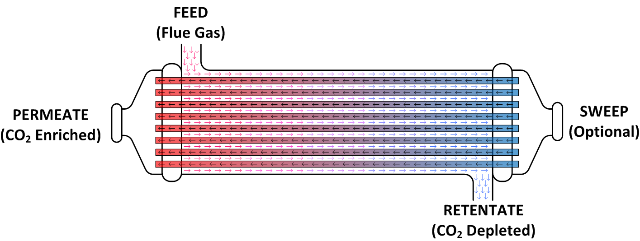

Figure 1: HFGP membrane device model schematic.

* 1. System/Installation Requirements

The minimum suggested hardware requirement is a desktop/laptop running Windows® 7 on Intel®   
Core i-5 family 2.8 GHz or faster and 8 GB of RAM. With a lower configuration, the simulation speed can be slower. The Aspen Custom Modeler® (ACM, Aspen Technology, Inc.) has been tested on Aspen V8.4.

* 1. Model Assumptions

The main assumptions of the HFGP Membrane Model are listed as follows.

* The feed gas enters the shell side of the hollow fiber membrane and permeates to the fiber’s bore. The sweep gas (optional) enters the fiber bore side at the opposite end from the feed. The gases in the retentate (shell) and permeate (fiber bore) sides flow from one discretized node to the next in the direction of flow accumulating to form the retentate and permeate outlet streams   
  (counter-current flow).
* The fibers that make up the bundle are identical, perfectly straight, and uniform diameter, cylindrical hollow tubes. The feed gas mixture is evenly distributed throughout a cross section of the fiber bundle. This is the starting point of the discretized length domain of integration. The end point is at the retentate outlet stream. Radial concentration and flow gradients in the fiber bundle are neglected (the problem is reduced to one dimension).
* Under the expected operation conditions, the gas mixtures in the module are assumed to behave ideally. The driving force for gas permeation is the difference of component partial pressure across the dense skin.
* The properties and state variables are constant at each node of the discretized axial domain.
* The dense skin layer of the asymmetrical hollow fiber membrane faces the shell side. The molar composition at the boundary of the dense skin layer and the porous support is equal to the bulk molar composition at the fiber bore. This assumption implies that there is no flux resistance imposed by the porous support.
* The pressure in the fiber bore varies due to constrained flow and can be described by the   
  Hagen-Poiseuille equation for a compressible fluid. Similarly, the pressure drop in the shell side is related to the velocity in the shell side by introducing hydraulic radius into the   
  Hagen-Poiseuille equation.
* The model is isothermal (no energy balance equation is considered).

1. Model Structure

The developed model was implemented in ACM and all PDEs are solved using method of lines. The spatial domain has been discretized using a 2nd order centered finite difference method and 20 elements are used as a default. The ACM file includes a newly-defined initialization parameter type, as well as the main device models. The model equations are written in the Custom Modeling library.

To find an HFGP Membrane Model in the Custom Modeling library:

1. In the “All Items” pane of the “Simulation Explorer,” confirm the Custom Modeling library is expanded and then expand the “Models” folder. A list of all the models in the current simulation displays.
2. Click either “HFGPnoS” or “HFGPw_S.”
3. In the “Contents” pane, double-click the icon that looks like an equal sign to view the model syntax.
   1. IO Structure and Reactor Dimensions

There are two versions of the model. One is defined with a sweep stream port and a second one without the port. Each port has associated variables that correspond to the material connection stream variables. The gas inlets and outlets are defined using the built-in ACM mole fraction port.

Given the equation oriented nature of this implementation, this model can be used to perform either rating or design calculations as long as the corresponding variables are specified as fixed to satisfy the degrees of freedom required for the solution.

* 1. Membrane Transport Model

The asymmetric membrane architecture found in modern gas permeation devices was developed to address conflicting requirements. Membrane thickness must be sufficiently thin to achieve high permeation rates but sufficiently thick to be mechanically stable and endure the imposed pressure gradient. By coating a thin (0.5-1 *μ*m) selective layer on a porous support two to three orders of magnitude thicker both requirements are fulfilled. Figure 66 below shows a simplified sketch of the asymmetric membrane architecture.

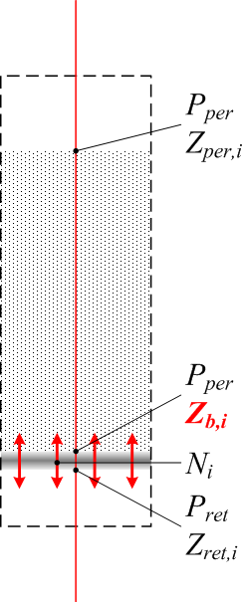

Figure 2: Asymmetric membrane.

The transport across the selective layer is assumed to follow the solution-diffusion model as described by Baker (2004). The permeance, *Q*, is the permeability divided by the layer thickness. Another important assumption of the solution-diffusion model is that the rates of adsorption and desorption are much higher than the permeation rate. Therefore, the compositions at the boundaries of the selective layer are at equilibrium with its immediate surroundings. Equations (1)–(3) describe the asymmetric membrane model.



The molar composition at the boundary of the porous support and the dense skin (*Zb,i*) is assumed to be equal to the bulk composition at the fiber bore. This may not be a valid assumption for a system with high fluxes (high partial pressure ratio and/or component permeances) or a Knudsen diffusion limited systems (porous support with relative large thickness and/or small mean pore radius).

* 1. Membrane Module Model

There are two types of industrial gas permeation modules suitable for this application: hollow fiber and spiral wound. Baker (2004) gives a complete description and comparison for these and other types of industrial membrane modules. From a modeling perspective, a hollow fiber module system is advantageous because the permeate pressure drop effects can be described from basic principles, and the flow patterns can be described in one dimension. For a spiral wound module, the permeate pressure drop is a function of the number and dimensions of the wound membrane envelopes and the spacer material. This information is typically proprietary and is therefore difficult to find. The permeate flows along the spiral on a plane perpendicular to the flow in the retentate side, which may require an additional dimension to be accurately described.

The equations that describe the hollow fiber module along the module length, *x*, under the assumptions above are:

|  |  |
| --- | --- |
| (4) |  |
| (5) |  |
| (6) | e |
| (7) |  |
| (8) |  |
| (9) |  |

Where

Equations (4)–(9) are the basis for the model. Boundary conditions, physical properties procedure calls, and other equations are written in the model syntax using the same nomenclature as the equations in this document.

* 1. Hollow Fiber Module Properties

The permeation properties and dimensions of the hollow fiber membrane are treated as lumped parameters of the model.

Table 30 includes the values assigned to each of these model variables. Selectivity is defined as the ratio of the permeance for CO2 to the permeance for a given gas species.

Table 1: Hollow Fiber Module Properties

| Variable | Typical | Base Case |
| --- | --- | --- |
| Inner Fiber Diameter (μm) | 100-700* | 400 |
| Outer Fiber Diameter (μm) | 200-800* | 600 |
| Effective Fiber Length (m) | 0.15-1.50* | 1.00 |
| CO2 Permeance (GPU) | 10-10000† | 1000‡ |
| H2O Selectivity | <1 | 0.5 |
| N2 Selectivity | 4-150† | 50‡ |
| O2 Selectivity | N/A | 50 |
| * Chowdhury et al., 2005 † Brunetti et al., 2010 ‡ Merkel et al., 2010 | | |

1. Tutorial

This section provides a detailed tutorial to simulate the performance of a two-stage membrane system in series. This tutorial was developed using ACM V8.4 and Aspen Properties® V8.4, additional modifications could be required when using different versions.

1. Open a new “ACM” file from the “Windows Programs” folder.
2. Define the Component List and Property Method.

In the “All Items” pane of the “Simulation Explorer,” select the “Component Lists,” and then double-click “Configure Properties” in the “Components List” pane. The “Physical Properties Configuration” window displays. Select “Use Aspen property system” in the dialog box and then click “Edit using Aspen Properties.” A new Aspen Properties file displays. In the “All Items” pane under “Components,” click “Specifications.” In the window that displays, click the “Selection” tab, under the “Component ID” tab type “CO2,” and then press “Enter.” This populates the “Type,” “Component name,” and “alias” fields. In the subsequent rows under “Component ID,” type “H2O,” “N2,” and “O2” in the same manner. In the “All Items” pane, click “Methods.” In the window that displays, select the “Global” tab, under the field “Method Name” click the drop-down arrow, and then select “PENG-ROB.” Double-click “Method” in the “All Items” pane. Double-click “Parameters” in the drop-down menu and then double-click “Binary Interaction.” Click the “half-filled red circle” icon for PRKBV-1. This turns the   
half-filled red circle to a completely filled blue circle with a tick mark through the circle. This ensures that Aspen Properties has populated all the required binary interaction parameters from its database. Run the property calculation by clicking “Run” or pressing “F5.” Confirm at the bottom of the window beside the “Check Status” tab, that the following message “Results Available” displays. Click “Save.” In the window that displays, Aspen Properties asks if the user also wants to save the file in Aspen Properties Document format. Select “No” and then close the window. This closes Aspen Properties. The “Physical Properties Configuration” window displays with a green box under the “Properties” status that indicates that the properties have been successfully configured. Click “OK.”

Open the “Default component” list dialog box by double-clicking “Default” under “Component Lists” in the “Simulation Explorer,” and then move all of the available components into the list on the right side of the dialog box.

1. Change the Non Linear Solver from Standard to DMO.

For this, open the “Solver options” dialog box by pressing “F10” and then change the “Non linear solver” from “Standard” to “DMO” in the “Non Linear solver” tab. Click “OK.”

1. From the “File” menu, click “Import Types.” Browse and then select “HFGP.acmf” in the folder where it was saved. Click “Open.” Ignore any warnings that appear in the “Simulation Messages” window stating that content that is not relevant to the Custom Modeling library was ignored.
2. Place an HFGPnoS Block on the “Process Flowsheet Window.”

In the “All Items” pane of the “Simulation Explorer,” double-click “Custom Modeling,” and then from under “Models” drag and drop the “HFGPnoS” model onto the “Process Flowsheet” pane.

Rename the model “M1.” Renaming in ACM is achieved by right-clicking an “item” and then selecting the “Rename” option, or by pressing “Ctrl+M” once the item is selected. Exchange the icon by selecting the “block” and then pressing “Ctrl+K.”

1. Specify the M1 Device Variables.

Double-click “M1.” On the “Device Variables” window enter the values as listed in Table 31.

Table 2:M1 Device Variables

| Variables | Values |
| --- | --- |
| alpha(“CO2”) | 1.0 |
| alpha(“H2O”) | 0.5 |
| alpha(“N2”) | 50 |
| alpha(“O2”) | 50 |
| CCfct | 0.51 |
| Dfi | 0.0004 |
| Dfo | 0.0006 |
| L | 1 |
| Qcd | 0.12047 |

**Note:** The fiber diameters are defined in meters while the CO2 permeance is defined in ACM default units (1000 GPU = 0.12047 kmol/m2/hr/bar). CCfct is a custom variable defined as the fraction (mol basis) of CO2 that leaves in the permeate outlet stream with respect to the CO2 at the feed inlet.

1. Specify the M1 Stream Variables.

Connect the inlet and outlet streams to the device model by dragging the “Connection type streams” from the “Stream Types” folder of the “Custom Modeling library” onto the port of the device model in the “Process Flowsheet Window.” There is only one feed port. Connect one stream to the feed port and name the stream “FeedM1.” When connecting the stream to the outlet port, a window displays with two choices. Select “Permeate” and then rename the stream “PermeateM1.” Connect another stream to the outlet and name the stream “RetenateM1.” To rename a stream in ACM, select the “stream,” right-click, and then select “Rename Stream.”

Double-click the “feed inlet stream” and then enter the values as listed in Table 32. Once the values have been entered, change the variable “Spec” value from “Free” to “Fixed.”

Table 3: M1 Gas Feed Specification

| Variables | Value | Units |
| --- | --- | --- |
| FeedM1.F | 100,000 | kmol/hr |
| FeedM1.P | 2.0 | bar |
| FeedM1.T | 50 | °C |
| FeedM1.z(“CO2”) | 0.19 |  |
| FeedM1.z(“H2O”) | 0.04 |  |
| FeedM1.z(“N2”) | 0.72 |  |
| FeedM1.z(“O2”) | 0.05 |  |

Specify the Permeate outlet stream pressure. Double-click the “PermeateM1 stream” and then enter “0.2” for “P” in the “PermeateM1.AllVariables Table.” Change the “Spec” from “Free” to “Fixed.”

1. Run the Simulation.

The simulation is ready to be solved. This can be verified by the presence of a green square at the bottom of the “ACM” window. However, the ACM solver cannot reach a solution from this point due to the size and non-linear nature of the problem. Verify this by running the simulation (press “F5”).

Reset the simulation (press “Ctrl+F7”). This changes the value of the free variables to the default values.

A solution procedure with a custom initialization method is defined using a Visual Basic® script. The script solves the model in incremental steps of complexity by using initialization procedure selectors. The selectors are switched from an “Initial” state that selects a set of simplified model equations to “Rigorous” which selects a set of more accurate equations corresponding to the desired solution. In the HFGP Model this script has two steps. The first one applies to the equation for the permeate side molar balance, and the second one applies to the permeate side pressure drop.

1. Invoke the IPsolve Script.

Right-click the “M1 block,” select “Scripts,” and then click “IPsolve.” Once the script is completed, the desired solution has been achieved.

1. Place an HFGPw_S Block on the “Process Flowsheet Window.”

Drag the “HFGPw_S model” from the “Models” folder of the “Custom Modeling library” in the “Simulation Explorer” panel onto the “Process Flowsheet” pane.

Rename the model (“Ctrl+M”) “M2” and then exchange its icon (“Ctrl+K”).

1. Specify the M2 Device Variables.

Double-click “M2.” On the “Device Variables” window enter the values as listed in Table 33.

Table 4: M2 Device Variables

| Variables | Value |
| --- | --- |
| alpha(“CO2”) | 1.0 |
| alpha(“H2O”) | 0.5 |
| alpha(“N2”) | 50 |
| alpha(“O2”) | 50 |
| CCfct | 0.86 |
| Dfi | 0.0004 |
| Dfo | 0.0006 |
| L | 1 |
| Qcd | 0.12047 |

1. Specify the M2 Stream Variables.

Connect M1’s Retentate outlet stream to the Feed port of M2. Select the stream “RetenateM1,” right-click, select “Reconnect Destination,” and then try to connect to the feed port of M2. A window displays. Select “Feed” and then click “OK.”

Connect one more feed stream and two outlet streams to M1 similar to M2. Name the feed stream “SweepM2.” Name the outlet streams “RetenateM2” and “PermeateM2.”

Double-click the “sweep inlet stream” and then enter the values as listed in Table 34 (composition of air). Once the values have been entered, change the variable “Spec” value from “Free” to “Fixed.”

Table 5: Gas Sweep Specification

| Variables | Value | Units |
| --- | --- | --- |
| SweepM2.F | 65,000 | kmol/hr |
| SweepM2.P | 1.3 | bar |
| SweepM2.z(“CO2”) | 0.00030 |  |
| SweepM2.z(“H2O”) | 0.01009 |  |
| SweepM2.z(“N2”) | 0.78223 |  |
| SweepM2.z(“O2”) | 0.20738 |  |

1. Run the Simulation by invoking the “IPsolve” script. Right-click the “M2” block, select “Scripts,” and then click “IPsolve.” Once the script is completed, the desired solution has been achieved.

Double-click the streams “PermeateM2” and “RetenateM2” to ensure that the results shown in Figures 67 and 68 below are obtained.

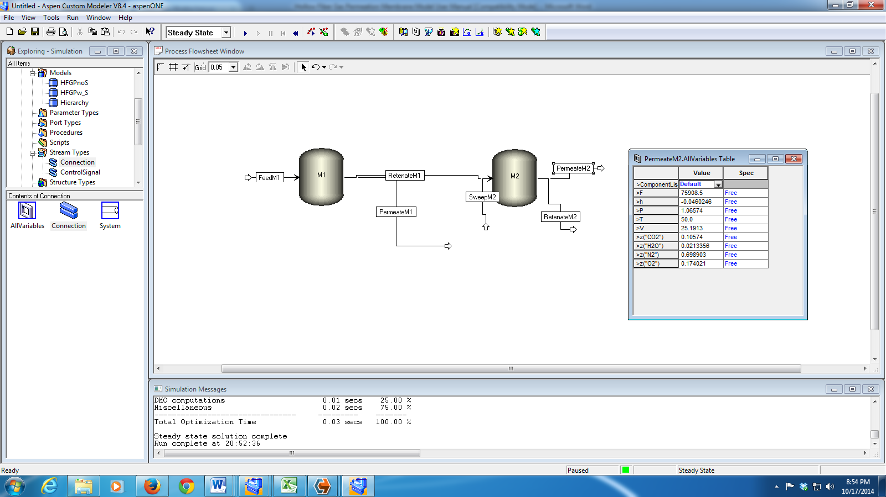

Figure 3: PermeateM2 stream results.

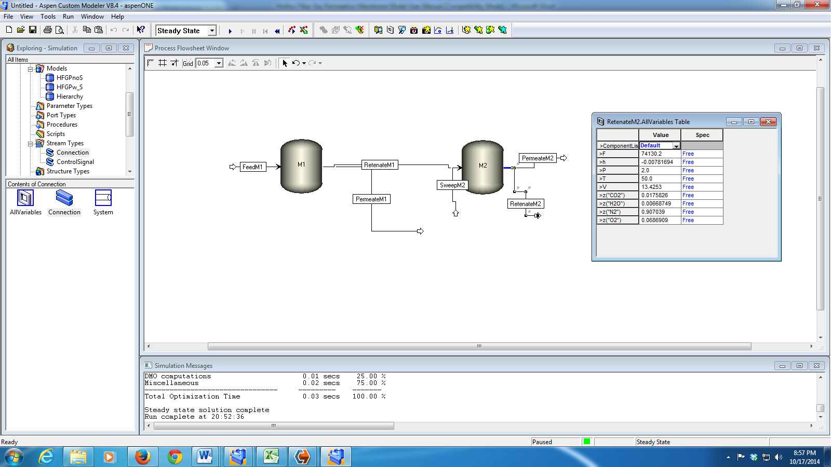

Figure 4: RetenateM2 stream results.

1. References

[1] Baker, R.W., *Membrane Technology and Applications*,2nd Ed., Wiley, Chichester, 2004.

[2] Brunetti, A., Scura, F., Barbieri, G., and Drioli, E., “Membrane Technologies for CO2 Separation,” *Journal of Membrane Science*, 2010, 359, p. 115–125.

[3] Chowdhury, M.H.M., Feng, X., Douglas, P., and Croiset, E., “A New Numerical Approach for a Detailed Multicomponent Gas Separation Membrane Model and Aspen Plus Simulation,” *Chemical Engineering and Technology*, 2005, 28, p. 773–782.

[4] Merkel, T.C., Lin, H., Wei, X., and Baker, R., “Power Plant Post-Combustion Carbon Dioxide Capture: An Opportunity for Membranes,” *Journal of Membrane Science*, 2010, 359, p. 126–139